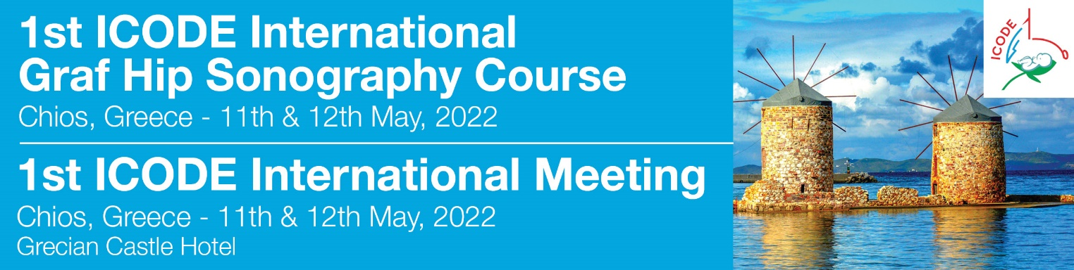

**ACCOMMODATION FORM**

*please send this form to MikaTravel*

For further information regarding your accommodation please contact: Mrs Eva Gouvianaki MikaTravel - **e mail:**  [congress@mikatravel.eu](mailto:congress@mikatravel.eu) **Tel.**: + 30 2810223356

|  |  |
| --- | --- |
| Mr /Mrs  Last Name/First Name: | |
| Tel.: | Mobile: |
| e-mail: | |
| Accompanying person:MrMrs  Name: | |

**GRECIAN CASTLE** suggested hotel

|  |
| --- |
| **Price per day Price includes** |
| Single room **82 €**  Double room  **95 €** Bed & Breakfast |
| Overnights from __________ to _________ Total overnights ___________ |
| **TOTAL** for accommodation **or DEPOSIT ------------------** €  For confirmation a deposit of minimum 1 night is necessary |

**METHOD OF PAYMENT**

**By Bank transfer to the order of DIMITRA MYKONIATI – MIKA TRAVEL**

(please enclose a copy of the bank transfer. Please state your name and Congress title on the bank transfer)

**EUROBANK ERGASIAS**

IBAN:**GR4902600200000110201259910**

BIC: **ERBKGRAAXXX**

Account Name : Dimitra Mykoniati (Mika Travel)

**If you wish to pay by credit card, please contact us.**