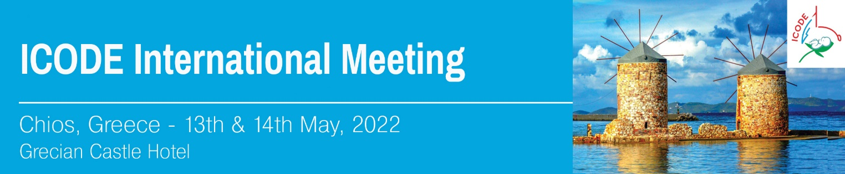

**REGISTRATION FORM**

*please send this form to MikaTravel*

For further information regarding the registration please contact:

Mrs Eva Gouvianaki - MikaTravel

**Email:**  [congress@mikatravel.eu](mailto:congress@mikatravel.eu) **Tel.**: + 30 2810223356

|  |  |
| --- | --- |
| Mr /Mrs  Last Name:  First Name: | |
| Affiliation : | |
| Tel.: | Mobile: |
| e-mail: | |

**\***FREE REGISTRATION